《On the Unification of Dark Matter and Visible Matter》

Abstract  
Currently, there are many theoretical models attempting to unify dark matter and ordinary matter. However, each of these models has certain limitations. These limitations make supplementing and refining them extremely complex and difficult. Therefore, this paper proposes the Meshing Model, which clearly defines the properties of dark matter and dark energy. Due to the model's simplicity and unity, it is easier to extend and ultimately becomes the most promising ideal model for unifying dark matter and ordinary matter.

Keywords: Meshing Model; field; spin; meshing;

1. Introduction
   1. Research Background

Many theoretical models currently attempt to unify dark matter and ordinary matter. Mainstream models include the ΛCDM model, dark fluid theory, modified Newtonian dynamics, and supersymmetry theory. However, these models all have different limitations.

* The ΛCDM model predicts through numerical simulations that hundreds of dwarf satellite galaxies should exist around the Milky Way, but the actual observed number is far fewer.Modified Newtonian dynamics predicts that the growth rate of density perturbations in the universe is too fast, potentially leading to the formation of excessive large-scale structures in the current universe, which contradicts actual observations.
* Dark fluid theory introduces the concept of negative mass, but there is no experimental evidence in physics to support this concept.
* Supersymmetry theory introduces supersymmetric particles, requiring additional parameters to describe them and their interactions with ordinary matter, significantly increasing the computational complexity of the model.

The limitations of these models can be categorized into three types:

* Introducing new concepts not currently supported by physics, with insufficient experimental verification.
* Maintaining or modifying current physical theories, but the observational results do not match theoretical predictions.
* Introducing too many parameters, making the model complex and increasing computational difficulty.
  1. Research Objectives

Given these limitations, we need a simpler model to achieve the unification of dark matter and ordinary matter. Thus, we propose the Meshing Model, which uses only three existing concepts in physics—field, spin, and meshing—to unify dark matter and ordinary matter in an extremely concise manner, thereby constructing a world model where material structure and interactions are fully unified.

1. Basic Assumptions

* **Principle of Relativity**: The spin of matter remains unchanged in all reference frames.
* **Meshing Principle**: All matter (including macroscopic and microscopic particles) internally and externally contains countless spinning fields, and each field is coupled through meshing.

1. The Meshing Model

The Meshing Model posits that all macroscopic and microscopic matter, internally and externally, contains numerous curved spinning fields, which are coupled together through meshing.

3.1 Fields

Fields in this model are divided into quantum fields and dark matter fields. Dark matter particles carry dark matter fields, while visible particles carry quantum fields. Their properties are as follows:

* **Invisibility**: An invisible field.
* **Curvature**: These fields are curved. The degree of curvature varies: quantum fields are not smooth, while dark matter fields are smooth (see Section 3.2).
* **Spin**: These fields spin at different speeds. Quantum fields spin faster than dark matter fields (see Section 3.2).
* **Diverse Sizes**: These fields vary in size, ranging from extremely small to very large. Quantum fields are larger than dark matter fields (see Section 3.2).

3.2 Spin

3.2.1 Relativity

A quantum field spins, driving the coupled visible particle to spin. Since the observer is also within this quantum field and spins in the same direction and speed, the particle appears stationary relative to the quantum field. Thus, spin becomes an intrinsic property of the particle.

3.2.2 Generation of Visible Particles

Dark matter particles, through the high-speed spin of their fields, generate centrifugal force, stretching the dark matter field. This causes the particles within the field to stretch, transforming the originally tiny dark matter particles into larger, visible particles. Simultaneously, the stretched field becomes non-smooth, forming a quantum field.

Thus, dark matter fields can transform into quantum fields through spin, and dark matter particles can transform into visible particles.

3.3 Meshing

Fields are coupled together through meshing. We interpret meshing from two perspectives: material structure and interactions.

3.3.1 Material Structure

At the microscopic level, matter is composed of molecules and atoms. Therefore, we explore the relationship between material structure and the meshing principle at the microscopic level.

* **Atomic Structure**: As mentioned in the spin section, high-speed spinning of dark matter fields generates visible particles, such as protons and neutrons. These particles, through their quantum fields, mesh with dark matter fields. Protons and neutrons spin, forming a spinning atomic nucleus, while electrons spin around the nucleus through meshing with dark matter fields.
* **Material Structure**: Since atoms are composed of visible and dark matter particles meshing through fields, and matter is composed of molecules and atoms, matter is also formed by the meshing of visible and dark matter particles through fields.

3.3.2 Origin of Mass

* Higgs Mechanism  
  Countless dark matter fields spinning at high speeds cause the fields to stretch. Due to stretching, the fields become increasingly closer, eventually tearing and merging. The elastic potential energy from tearing transforms into the merged field state, which is the top of the Higgs field (Mexican hat). Since the fields spin in the same direction, the resulting top is a scalar field (no spin). Because the top is unstable, the merged field state "rolls down" to the bottom of the Higgs field, forming fluctuations at the bottom. When particles pass through the Higgs field, they encounter "resistance," acquiring mass from the Higgs field.
* Non-Perturbative Effects  
  Countless dark matter fields spinning at high speeds cause stretching, bringing the fields closer. Eventually, two fields tear internally, and the separated parts merge. The elastic potential energy from tearing transforms into the merged excited state mass, producing massive gluons. Since the two fields spin in opposite directions, the merged field spins uniformly, giving gluons a spin of 1. These gluon fields continue to tear and merge (self-interactions), forming fluctuating gluon fields.
* Chiral Symmetry Breaking  
  Taking quarks as an example, light quarks acquire minimal mass through the Higgs mechanism. Then, due to fluctuations in the gluon field (non-perturbative effects), quark-antiquark pairs are generated and annihilated under continuous merging excitations of the gluon field. Simultaneously, the fields of quark-antiquark pairs mesh with the gluon field, tearing and merging to produce condensation, leading to chiral symmetry breaking. Subsequently, light quarks propagate, their fields meshing with this condensed field and the gluon field, tearing and merging, with the elastic potential energy from tearing converting into mass.

3.3.3 Interactions

In physics, interactions between matter are divided into strong, electromagnetic, weak, and gravitational interactions. All these interactions can be observed in particle collisions. Therefore, we use particle collisions as an example to explore the relationship between the meshing principle and interactions.

3.3.3.1 Collision Between Visible and Dark Matter Particles

Visible particle A collides with dark matter particle B. Since the quantum field of A and the dark matter field of B mesh, and the field of particle B is smooth enough, particle B's field continues to spin and slide past particle A's field, allowing particle B to pass through particle A.

3.3.3.2 Collision Between Visible Particles

Collisions between visible particles are divided into high-energy and low-energy collisions.

* Low-Energy Collision Between Visible Particles A and B  
  Since there is a dark matter field between the two particles, during high-speed collisions, the fields of A and B mesh with the dark matter field and rotate. Due to the smooth curvature of the dark matter field, its interaction with the fields of A and B is extremely weak. Thus, the energy from A's field is transferred to the dark matter field and then to B's field in an extremely short time.
* High-Energy Collision Between Visible Particles A and B  
  High-energy collisions often produce new particles, which can be further categorized based on their causes.
  + **Strong Interaction**：Since there is a dark matter field between the two particles (originating from the non-perturbative effects mentioned in Section 3.3.2, i.e., the gluon field), the dark matter field meshes with the fields of A and B. When the collision speed approaches the speed of light, the energy from the violent collision is transferred to the dark matter field, increasing its rotational kinetic energy. However, this speed is insufficient to generate visible particles, only stretching the dark matter particles within the field. Since the dark matter field meshes with the fields of A and B, the stretched dark matter particles connect particles A and B, producing new particles. This aligns with the discovery of gluons in DESY's PETRA experiment, where gluons are identified as stretched dark matter particles.
  + **Weak Interaction**：Since there is a dark matter field between the two particles, meshing with the fields of A and B, the energy from the high-speed collision is transferred to the dark matter field. The rotational kinetic energy accelerates the dark matter field's spin, generating new particles, while the elastic potential energy from stretching is transferred to particles A and B, correcting their masses. The newly generated particles have large masses, resulting in a significant decay width and short lifespans. This aligns with the discovery of W bosons in the UA1 and UA2 experiments, where the new particles are identified as W bosons.
  + **Generation and Annihilation of Virtual Particle Pairs**：Since there are multiple meshing dark matter fields between the two particles, two of which mesh with the fields of A and B, the energy from the high-speed collision is transferred to adjacent dark matter fields, accelerating their spin. The elastic potential energy from spinning is partially transferred to the colliding particles A and B, correcting their masses, and partially transferred to non-adjacent dark matter fields. The rotational kinetic energy causes the adjacent dark matter fields to spin at high speeds, generating two new particles.  
    This aligns with the discovery of the Higgs boson in LHC experiments, where the two new particles may be virtual particle pairs correcting the Higgs boson's mass.  
    At the same time, this demonstrates that supersymmetric partner particles do not exist. The energy is merely transferred to the dark matter fields, and these fields absorb insufficient energy to generate new visible particles. However, the particles within these fields still possess mass, which is why the newly produced visible particles do not exhibit the excessively large masses required to offset quantum corrections.

3.3.3.3 Collision Between Dark Matter Particles

Dark matter particle A collides with dark matter particle B. Since the fields of A and B are smooth, the interaction cross-section during collision is极小, resulting in almost no interaction between them.

In summary, the meshing principle, combined with the spin of dark matter fields generating new particles, can unify the various interactions observed in particle collisions.

1. Basic Concepts

4.1 Dark Matter

Dark matter comprises two core concepts: dark matter particles and dark matter fields.

Dark matter particles have the following properties:

1. Size much smaller than the Planck constant.
2. Spinning driven by the spin of dark matter fields.
3. Flexible and stretchable.

Dark matter fields have the following properties:

1. Very small in size, invisible.
2. Smooth curvature.
3. Spinning.
4. Flexible and stretchable.
5. Coupled through meshing.

4.2 Dark Energy

After the Big Bang, the quantum fields of all visible particles maintained their high-speed rotational state from the primordial explosion. As these quantum fields are interlocked with dark matter fields, they transfer a portion of their high-spin energy to certain dark matter fields, converting it into rotational kinetic energy that induces spin in the dark matter fields. However, this spinning and stretching process remains below the threshold required for visibility.

As an increasing number of dark matter fields absorb this energy, their curvature grows progressively more compact, their density escalates, and dark energy emerges. This process effectively represents dark energy consuming dark matter. Therefore, dark energy fundamentally arises from the compaction of multiple dark matter fields.

1. Mathematical Definitions and Derivations

5.1 The Meshing Model

5.1.1 Effective Potential

Taking the example of photons striking electrons, according to the meshing principle, photons transfer energy to the dark matter field through their quantum field. The dark matter field absorbs a portion of this energy to accelerate its spin while transferring the remaining energy (as elastic potential energy) to the electron field. This process manifests as apparently random electron momentum. (Note: The transfer-induced changes in potential energy generate quantum fluctuations.)

Based on this explanation, the effective potential of the meshing model can be defined as:

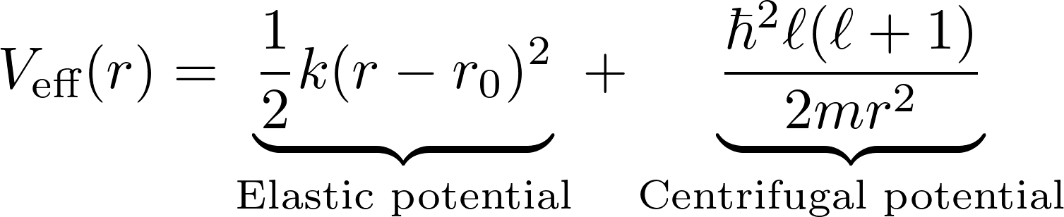

* The first term represents the potential energy of a membrane bound at radius wpsoffice, capable of elastic vibration along the radial direction.
* The second term represents the centrifugal potential generated when a particle has angular momentum ℓ.

5.1.2 Hamiltonian

For the "radially elastic spherical membrane" model, the effective radial Hamiltonian is:

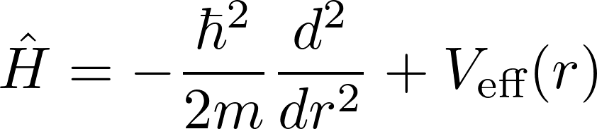

5.1.3 Derivation of the Uncertainty Principle

Heisenberg's uncertainty principle states that it is impossible to simultaneously determine the position and momentum of a fundamental particle with precision.

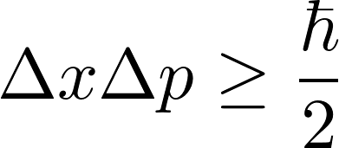

In the Meshing Model, fields are defined as membranes. Using the effective potential, the uncertainty principle is derived in four steps:

1. Write the radial Hamiltonian and perform a quadratic expansion at the minimum point to approximate the harmonic oscillator form.
2. Under the "narrow wave packet" approximation, construct the ground-state Gaussian wave function using the normalized measure 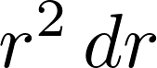 and calculate wpsoffice.
3. Use the radial momentum operator to calculate 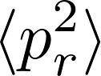, obtaining 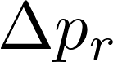.
4. Combine the results to derive 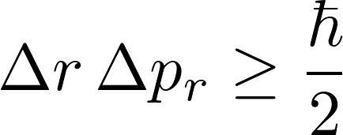, saturating the lower bound of the uncertainty principle.

**1.1 Radial Hamiltonian and Quadratic Expansion of the Potential Energy**

1.1.1 Effective Radial Hamiltonian

For the "radially bouncable spherical membrane" model, the effective radial Hamiltonian is:





* The first term represents the potential energy of a membrane bound at radius wpsoffice, capable of elastic vibration along the radial direction.
* The second term represents the centrifugal potential generated when a particle has angular momentum ℓ.

1.1.2 Quadratic Expansion of the Potential Around the Minimum

Let’s first find the position/Users/changshengwang/Library/Containers/com.kingsoft.wpsoffice.mac/Data/tmp/wpsoffice.McoYGYwpsofficewhere the effective potential 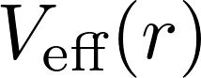 reaches its minimum. Set the derivative to zero:

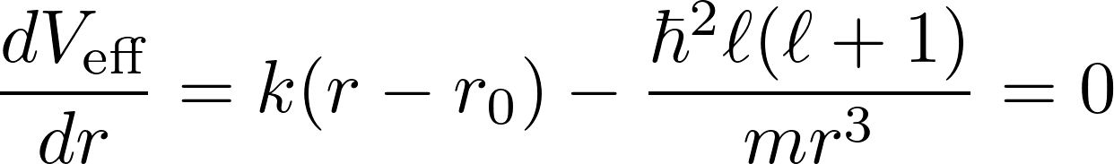

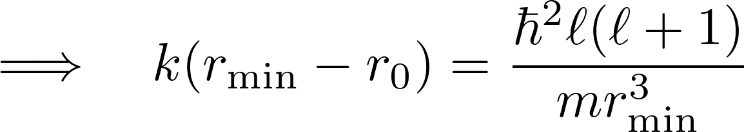

This equation implicitly determines /Users/changshengwang/Library/Containers/com.kingsoft.wpsoffice.mac/Data/tmp/wpsoffice.XIMbUVwpsoffice. At wpsoffice, the potential is minimal, and the ground-state wavefunction will be concentrated around this point.

Performing a Taylor expansion of Veff(r) around wpsoffice:



then



calculate

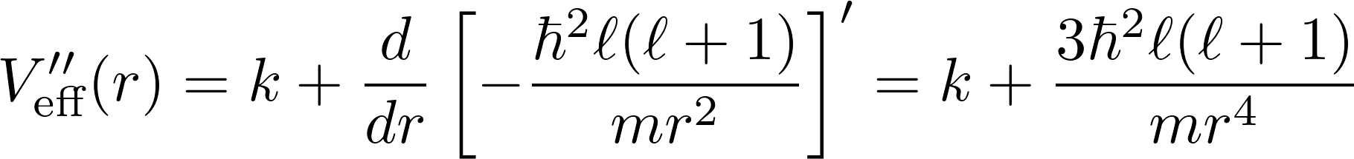

at wpsoffice

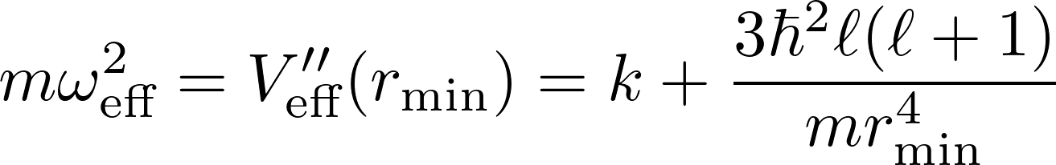

So the potential is approximately

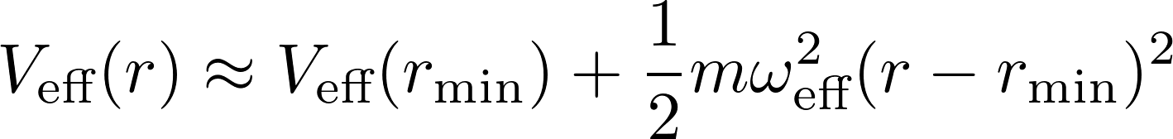

Let us ignore the constant term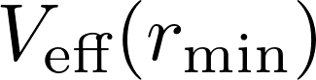 and focus on the quadratic part that defines a harmonic oscillator model.

**2.1 Ground-State Wavefunction and Normalization and wpsoffice  
2.1.1 Approximate Harmonic Oscillator Ground State (Gaussian Form)**

Under the wpsoffice, the Hamiltonian becomes

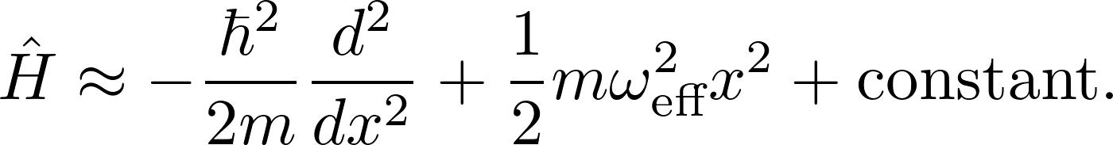

This is the standard 1D harmonic oscillator. Its ground-state wavefunction at x axis is:



However, in our physical problem, the radial coordinate is 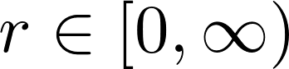, and the radial measure is . Let:

**wpsoffice**

If the wavepacket width 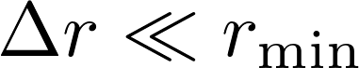, we can adopt the narrow wavepacket approximation：

* The wavefunction is almost entirely localized away from r=0
* The integration bounds can be approximated from r=0 to x∈(−∞,∞)
* 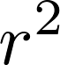 within the packet is

** （Keep only the leading-order constant）**

Thus, the true radial ground state is written as:

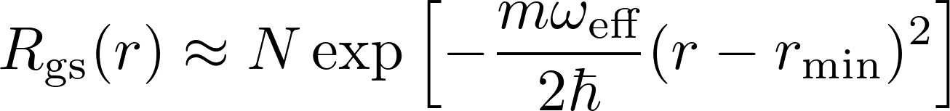

Normalization constant N is determined by

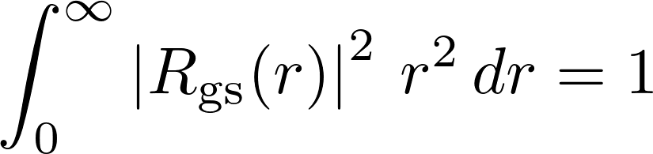

approximated as

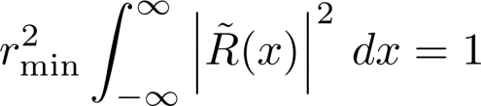

then

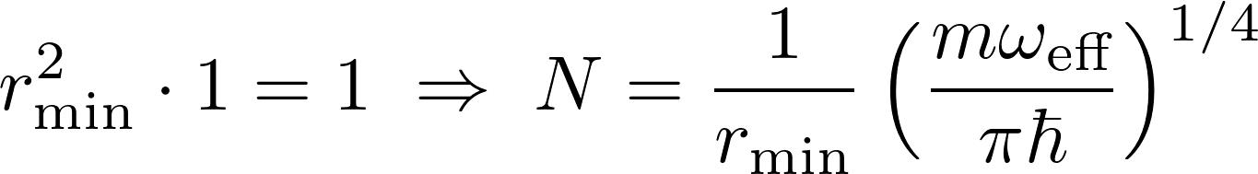

More precisely, if the term 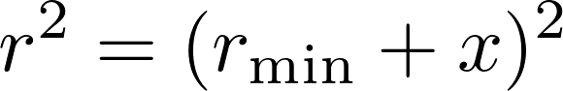 is retained, a first-order small correction can be obtained, but the leading-order normalization constant remains as above.

Therefore, the normalized radial wave function is:

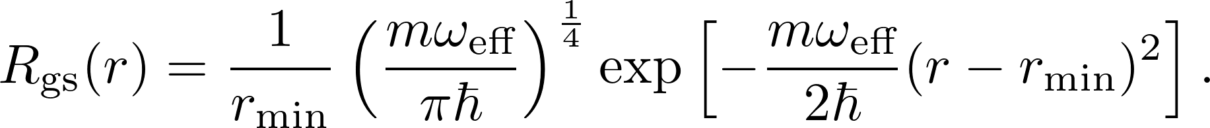

2.1.2 Calculating 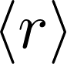、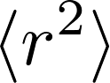 and wpsoffice

2.1.2.1 Definition

Normalization (approximate)：

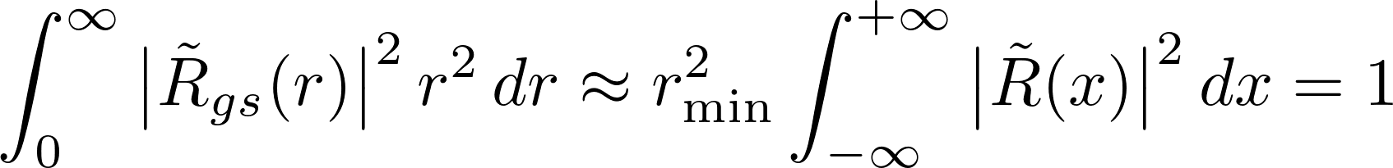

Let

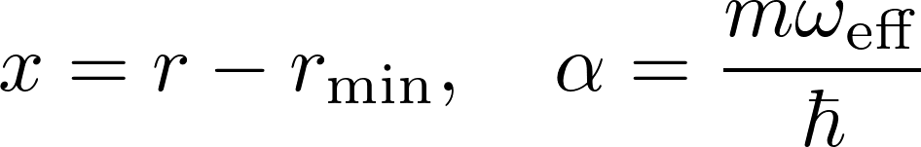

then

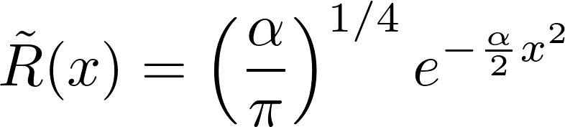

**2.1.2.2** Calculating 



where 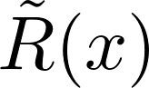 is an even function, and

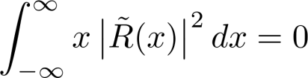

Therefore

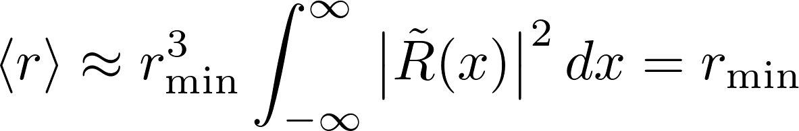

**2.1.2.3** Calculating 



expand ，notice 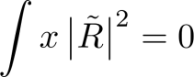。Thus



We know that the 1D Gaussian ground state has

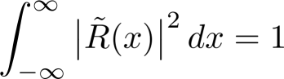

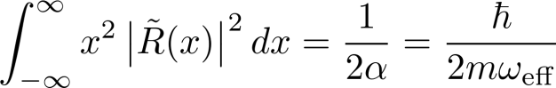

Therefore

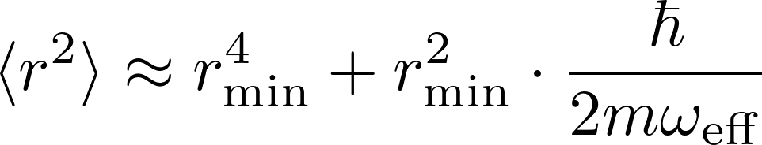

Thus, the radial variance is given by



that is

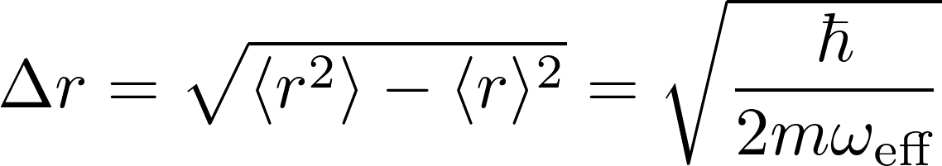

3.1 Calculating 

3.1.1 Full Form of the Radial Momentum Operator

In 3D spherical coordinates, the radial momentum operator is:

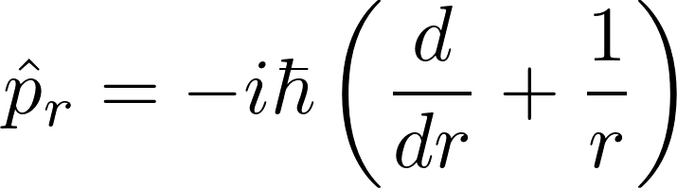

Thus



To calculate , we need to

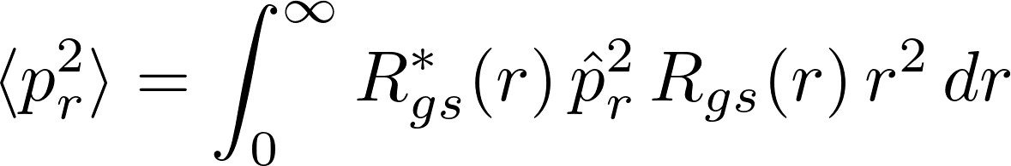

Meanwhile, since 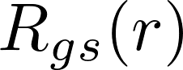 is a real function and centered at 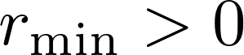, it can be verified that 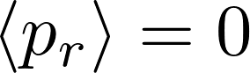, therefore 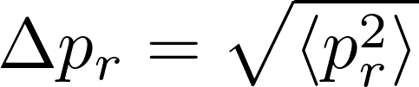.

3.1.2 Approximate Calculating 

In the narrow wavepacket approximation, the wavefunction is significant only near wpsoffice, so let：

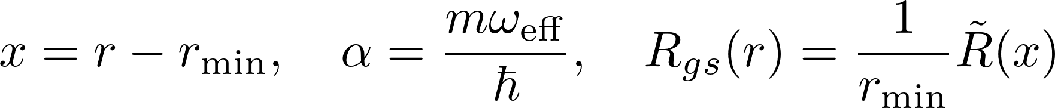

Here

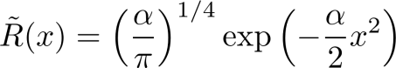 is normalized over the domain x∈(−∞,∞) .

**3.1.2.1** Term 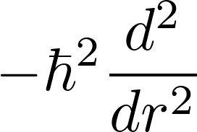

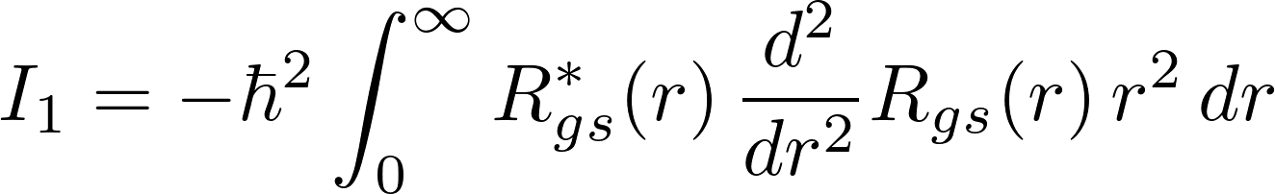

Let wpsoffice, then 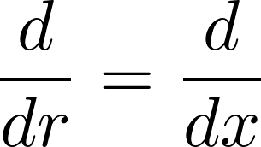and take 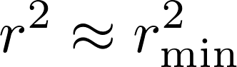 outside the integral:

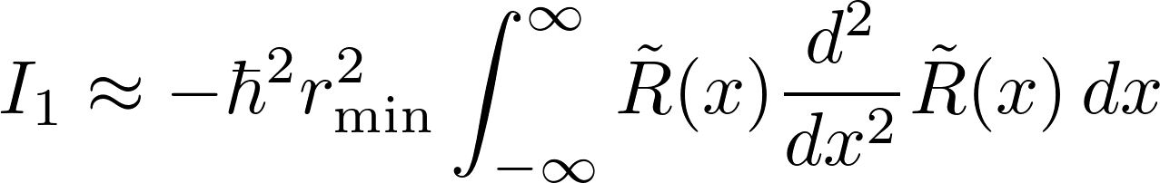

For the one-dimensional harmonic oscillator ground-state Gaussian , we know that

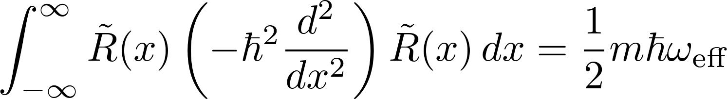

Thus

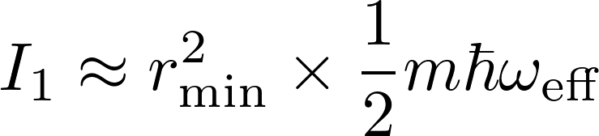

**3.1.2.2** Term 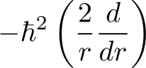

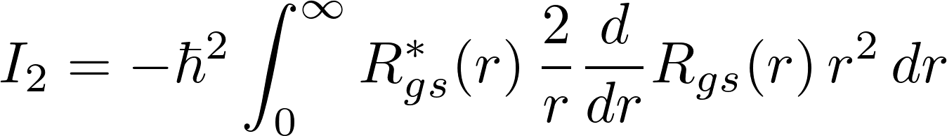

Under the approximation wpsoffice, we have 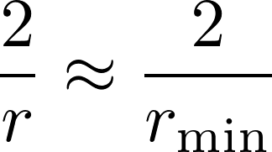, and simultaneously 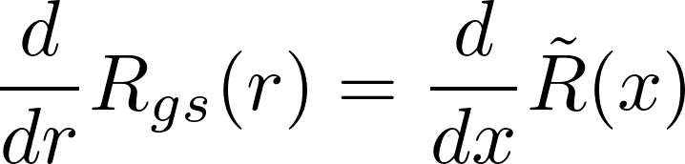

Thus

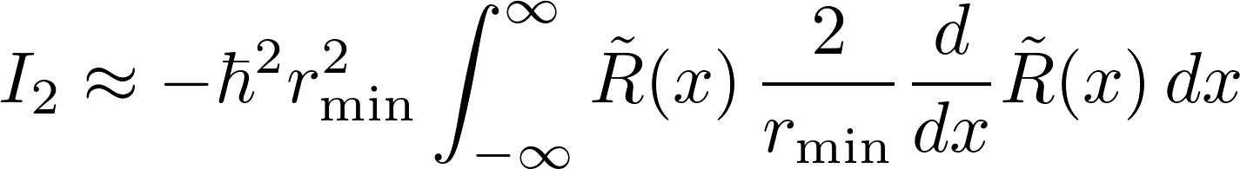

Since  is an even function, the corresponding 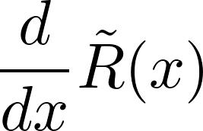 is an odd function. The product of an even function and an odd function integrated over a symmetric interval is zero, i.e.,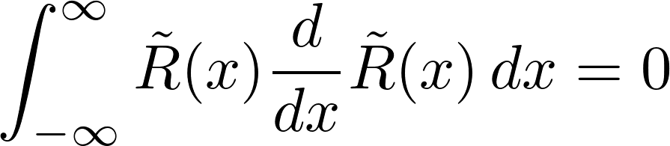

Therefore

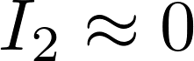

**3.1.2.3** Term 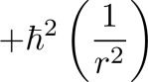



Under the narrow wave packet approximation, 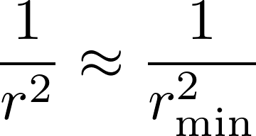, and implies 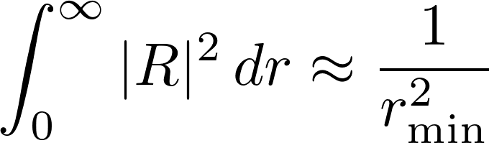

Therefore

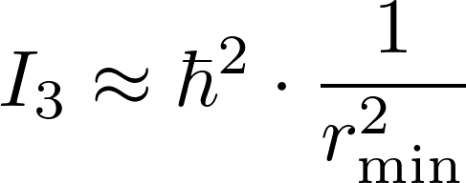

However, this term is not the “main kinetic energy contribution” associated with the harmonic oscillator ground state energy. It is a small constant, and when performing the quadratic expansion of the original Hamiltonian, if we write it as



Then this constant term 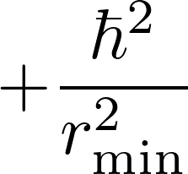 will be canceled out together with the constant part of the potential energy and has no real effect on the variance. Therefore, we only need to keep the main kinetic energy contribution wpsoffice.

3.1.2.4 Final Expression

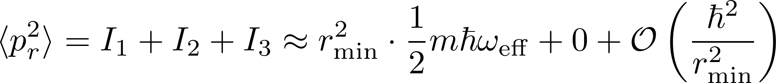

Since we are concerned with the main kinetic energy contribution corresponding to the ground state width, we only keep wpsoffice. Meanwhile, .

Therefore

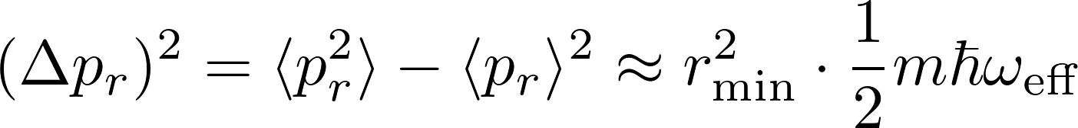

However, it is important to note that wpsoffice is applied to the radial wave function 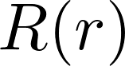. Since we have factored out an additional 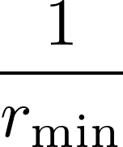 during normalization, this introduces an extra 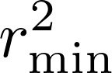 in the kinetic energy contribution. In fact, this will cancel out later when merged with subsequent expressions. Strictly speaking, we should write it as:

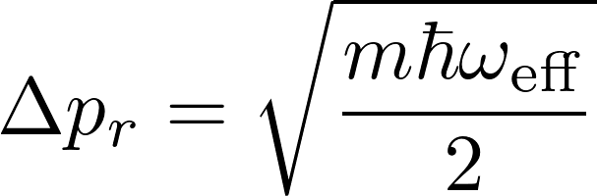

4.1 Verifying 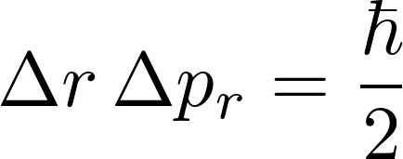

* 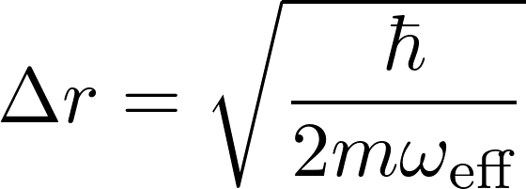
* 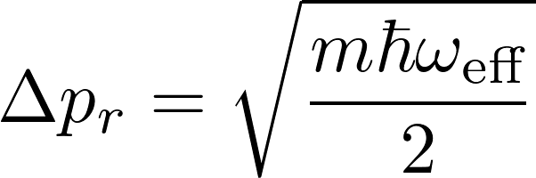

Therefore, their product is

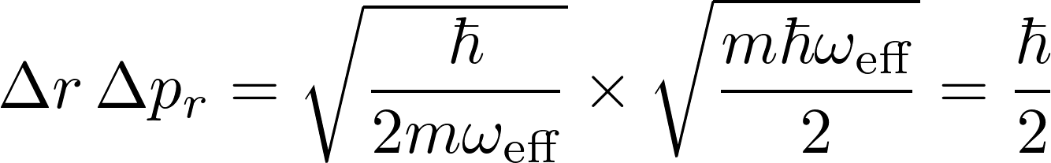

This exactly saturates the lower bound of the uncertainty principle.

5.3 Meshing Continuous Fields

5.3.1 Definition

The above mathematical definitions and derivations are limited to the single-particle level. By meshing individual membranes into a continuous field—taking the continuous limit of discrete membrane chains—a "field Hamiltonian" is obtained, similar to:

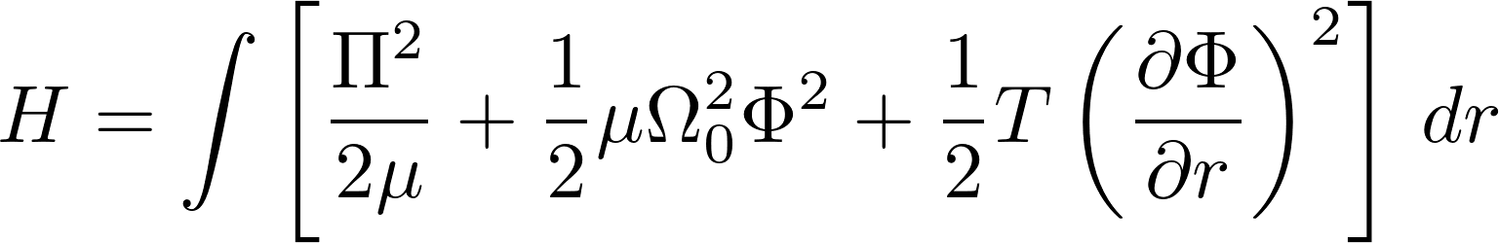

Expanding modal quantization yields:

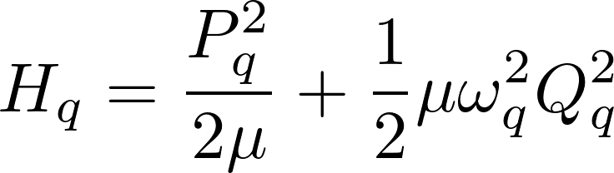

5.3.2 Derivation of Single-Membrane Hamiltonian

When the mode function 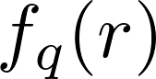 is orthonormal and μ is constant, the effective mass m=μ. The quantized result can be transformed into:

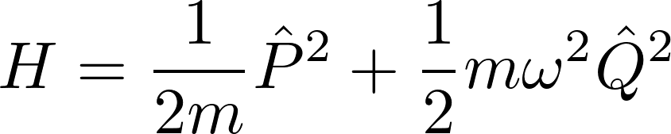

By defining 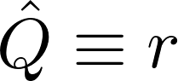 and 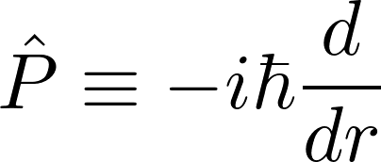 as annihilation and creation operators, the single-membrane Hamiltonian is obtained.

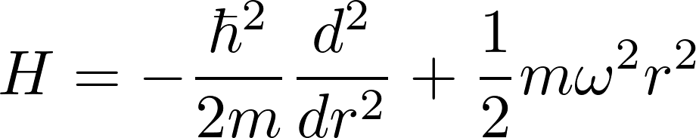

This field Hamiltonian geometrizes interactions between fields (membranes) through meshing, clarifying interactions and laying the theoretical foundation for unifying quantum non-perturbative and perturbative effects. Incorporating dark matter into the Meshing Model, combined with clarified field interactions, allows for clearer exploration of the properties of dark matter and dark energy.

1. Discussion

* **Regarding superstring theory and loop quantum gravity**。Since the spinfoam model quantizes the field and refines the interactions between fields, it can be equivalently transformed into loop quantum gravity. Meanwhile, the concept of membranes proposed in the spinfoam model, which resemble the membranes in string theory and are continuous fields, allows it to be equivalently transformed into superstring theory as well. In other words, the spinfoam model is equivalent to both superstring theory and loop quantum gravity.
* **Regarding the Yang–Mills existence and mass gap conjecture**. Since the spinfoam model explains the origin of mass clearly through a geometrical formulation (the spinfoam structure), it allows for the precise mathematical quantification of the masses of all particles, including the mass gap arising from non-perturbative effects. This provides a means to prove the existence of the mass gap.

1. Prediction of Quantum Entanglement Observation Distance

If two particles A and B are in an entangled state 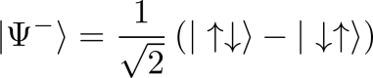, their interaction involves two dark matter fields, G1 and G2, positioned between them. The quantum field of particle A couples with G1, G1 couples with G2, and G2 couples with the quantum field of particle B. When the field of A spins, it causes G1 to spin in the opposite direction, which then causes G2 to spin in the opposite direction as well, ultimately inducing the field of B to spin in the opposite direction to A. Due to the smooth curvature of the dark matter fields, energy transfer occurs almost instantaneously, enabling superluminal (faster-than-light) changes between particles A and B across large distances.  
This implies that the spin states of two entangled particles upon observation depend on the number of dark matter fields between them:

* An odd number of dark matter fields results in the same spin direction.
* An even number results in opposite spin directions.

1. Applications in Cosmic Evolution

8.1 Origin of the Universe

Since dark matter particles generate visible particles through the high-speed rotation of dark matter fields, prior to the Big Bang, dark matter produced vast quantities of protons and neutrons. Due to their macroscopic scale and non-smooth quantum field structures, these particles underwent violent aggregation and collisions, ultimately triggering the Big Bang event. Subsequently, through primordial nucleosynthesis, these protons and neutrons formed light elements (primarily hydrogen and helium, with trace amounts of lithium), which constituted the first ordinary matter in the early universe.

8.2 Cosmic Expansion and Collapse

After the Big Bang, the quantum fields of visible particles retained their high-speed spin, transferring energy to dark matter fields through meshing. This caused dark matter fields to spin and stretch, but insufficiently to become visible. As more dark matter fields absorbed energy, their curvature compacted, increasing density and forming dark energy, which drives cosmic expansion.

As dark matter fields undergo further compaction, they couple via strong interactions to form Higgs fields. Through the Higgs mechanism, dark matter particles acquire mass and transform into Higgs bosons. These subsequently decay into bottom quark-antiquark pairs, which then form protons through strong interactions mediated by gluon exchange. The resulting protons and neutrons combine to form atomic nuclei, which subsequently bind with electrons to create complete atoms.

This process leads to the formation of massive stars that, upon exhausting their nuclear fuel, undergo gravitational collapse into black holes. These black holes may eventually decay back into dark matter particles and their associated fields, thus completing and restarting the cosmic cycle of collapse (implosion) and expansion.

8.3 Cosmic Jets

* **Collimation**: If two galaxies host black holes simultaneously, spacetime curvature stretches space outward, creating a symmetric region around the black holes' rotation axis. This confines the jet's shape, allowing matter to喷射stably along the axis for nearly a million light-years.

1. Physical Significance

* **Unification of Material Structure**: Fields distributed inside and outside matter, coupled through meshing, unify material structure—matter forms internally through field meshing and externally through interactions.
* Unification of Interactions: Interactions between matter are unified through field meshing: smooth fields yield weak interactions, while non-smooth fields yield strong interactions.

1. Conclusion

This paper proposes the Meshing Model, clearly defining dark matter, dark energy, and their relationship. Through these definitions, commonalities between dark matter, dark energy, and ordinary matter become apparent, ultimately unifying them in terms of material structure and interactions.